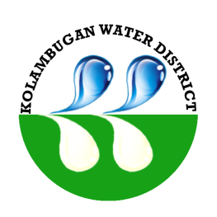
Republic of the Philippines
Kolambugan Water District
(GOVERNMENT OWNED & CONTROLLED CORP.)
Kolambugan, Lanao del Norte
TIN: 004-365-844 CCC No. 539

FLOW CHART

INSTALLATION OF NEW SERVICE CONNECTION
Fill up Request for New Service Connection
(Officer of the Day (OD))

Scheduling of Installation of New Water Service Connection by KOLWD Personnel
Disapproved Request: No water supply available
Site/location inspection for approval of request
(KOLWD Personnel)

Approved Request:
Fill up Water Service Contract Agreement

Orientation/Seminar for New Service Connection Applicant
Payment for the Registration Fee
(Teller)

