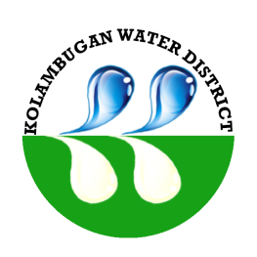
Republic of the Philippines
Kolambugan Water District
(GOVERNMENT OWNED & CONTROLLED CORP.)
Kolambugan, Lanao del Norte
TIN: 004-365-844 CCC No. 539

FLOW CHART

LEAK REPAIRS

Fill up Service Request
(Officer of the Day (OD))

Approved Request:
Scheduling of repair
Disapproved Request:
In house plumbing

Site/location inspection for approval of service request
(KOLWD Personnel)

