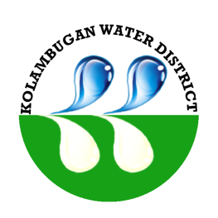
Republic of the Philippines
Kolambugan Water District
(GOVERNMENT OWNED & CONTROLLED CORP.)
Kolambugan, Lanao del Norte
TIN: 004-365-844 CCC No. 539

CERTIFICATION OF COMPLIANCE

ARTA Implementation

This certifies that KOLAMBUGAN WATER DISTRICT has complied and implemented the Republic Act No. 9485 “An act to Improve Efficiency in the Delivery of Governance Service to the Public by Reducing Bureaucratic Red Tape, Preventing Graft and Corruption, and Providing Penalties Therefore” together with its implementing Rules and Regulations and Administrative Order No. 241 issued October 2, 2008 by the Office of the President aim to facilitate and improve delivery of public service.

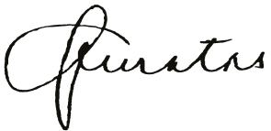
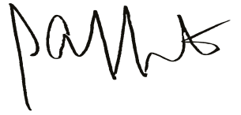

MA. JAEVA C. QUINTAS ENGR. LIONEL ALFREDO A. INFANTE HRMO – Designate General Manager

Republic of the Philippines
Kolambugan Water District
(GOVERNMENT OWNED & CONTROLLED CORP.)
Kolambugan, Lanao del Norte
TIN: 004-365-844 CCC No. 539

CERTIFICATION OF COMPLIANCE

SALN Submission/Filing

This certifies that 8 employees out of 8 employees of KOLAMBUGAN WATER DISTRICT covered by RA 6713 have filed their Statement of Assets, Liabilities and Net Worth (SALN) for FY 2014. The local water district has forwarded/filed all SALNs with the appropriate receiving entity (i.e. Ombudsman in the case of President, Vice President and Constitutional Officials, et.) in accordance with RA 6713 and its implementing rules and regulations.

This also attests that the submission of this agency’s employees have substantially complied with the minimum Rules and Regulations, which are as follows:

- Basic information
- Assets (Real Properties and Personal Properties)
- Liabilities
- Net Worth
- Financial Connections and Business Interests
- Relatives in the Government

Lastly, this certifies that this agency has already executed appropriate action against those who failed to comply with RA 6713 and have no justifiable reason not to comply.

IN WITNESS WHEREOF, we have hereunto affixed our signatures on the December 15, 2015 at Kolambugan Water District Office, Kolambugan, Lanao del Norte, Philippines.

MA. JAEVA C. QUINTAS ENGR. LIONEL ALFREDO A. INFANTE
Chairman Agency Head
SALN Review and Compliance Committee
HRMO-Designate

Republic of the Philippines
Kolambugan Water District
(GOVERNMENT OWNED & CONTROLLED CORP.)
Kolambugan, Lanao del Norte
TIN: 004-365-844 CCC No. 539

CERTIFICATION OF COMPLIANCE

TRANSPARENCY SEAL

This certifies that KOLAMBUGAN WATER DISTRICT has complied with the Transparency Seal Provision stated on Section 93 of the General Appropriation Act of FY 2012.

- the agency’s mandates and functions, names of its officials with their position and designation and contact information;
- annual reports, as required under National Budget Circular Nos. 507 and 507-A dated January 31, 2007 and June 12, 2007, respectively;
- the agency’s approved budgets and corresponding targets immediately upon the approval of the General Appropriation Act of FY 2012;
- major programs and projects categorized in accordance with the five key results areas under E.O. No. 43, s. 2011;
- the program/projects beneficiaries are identified in the applicable special provisions;
- status of implementation and program/project evaluation and/or assessment reports; and
- Annual Procurement Plan, contract awarded and the name of contractor/suppliers/consultants.

This Certification is being issued to attest to the truth and accuracy of all the information contained therein based on available records and information that can be verified.

This is to further certify that the same documents and information are posted in the website of the Kolambugan Water District with this uniform resource locator (URL): kolambugan-waterdistrict.com under a single Transparency Seal Icon, prominently located on the homepage of the aforementioned website and the same shall remain unchanged unless otherwise necessitated by circumstances, such as updates, clerical corrections, and similar causes.

IN WITNESS WHEREOF, we have set hereunto affixed our signatures this 15th of December 2015, at Kolambugan, Lanao del Norte, Philippines.

MA. JAEVA C. QUINTAS ENGR. LIONEL ALFREDO A. INFANTE HRMO – Designate General Manager

