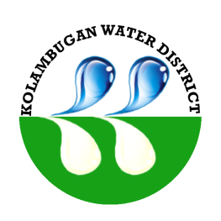
Republic of the Philippines
Kolambugan Water District
(GOVERNMENT OWNED & CONTROLLED CORP.)
Kolambugan, Lanao del Norte
TIN: 004-365-844 CCC No. 539

KOLWD PROGRAMS AND PROJECTS
As of December 31, 2015

No. | Project  Program  Activity Name | Location  Target Beneficiaries | Total  Cost |  | Date  Started | Status of Project Implementation
 |  |  |  |  |  | Target  Completion  Date | Actual  Completion Date |  | % of Completion | Total  Cost Incurred | Remarks
1 | Pipe Line Extension | Titunod to Libertad | P1,270,546.70 |  | January 2, 2015 | February 27, 2015 | February 28, 2015 |  | 100% | P1,270,546.70 | Fully Implemented
Total Project Cost P 1,270,546.70

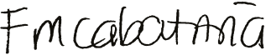  Prepared by:  FLORA MAY S. CABATAÑA  UCSA-D |  |  |  | 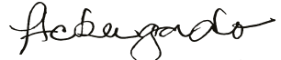  Checked by:  HERMINIA C. BERGADO  Corporate Accounts Analyst |  |  |  | 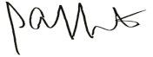  Approved by:  ENGR. LIONEL ALFREDO A. INFANTE  General Manager

