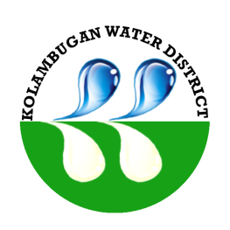
Republic of the Philippines
Kolambugan Water District
(GOVERNMENT OWNED & CONTROLLED CORP.)
Kolambugan, Lanao del Norte
TIN: 004-365-844 CCC No. 539

GUIDELINES/MECHANICS IN RANKING OFFICES/DELIVERY UNITS AND
INDIVIDUAL FOR THE GRANT OF PERFORMANCE-BASED BONUS (PBB)
FOR CY 2016

Guidelines and process in determining and evaluation of the performance ranking and rating of offices and employee within the Kolambugan Water District:

- Approved by the Civil Service Commission the Kolambugan Water District Guidelines in the establishment of Strategic Performance Management System

- Office Performance Commitment and Review - (January – June 2016)

- Office Performance Commitment and Review – (July – December 2016)

- Individual Performance Commitment and Review – (January – June 2016)

- Individual Performance Commitment and Review – (January – June 2016)

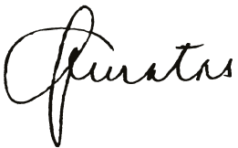
Prepared by:

MA. JAEVA C. QUINTAS
Human Resource Management Officer – Designate

Noted by:
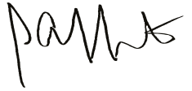

ENGR. LIONEL ALFREDO A. INFANTE (SGD) DIR. VICENTE P. MEJORADA
General Manager BOD Chairman

