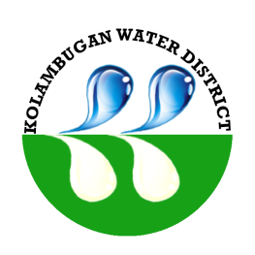
Republic of the Philippines
Kolambugan Water District
(GOVERNMENT OWNED & CONTROLLED CORP.)
Kolambugan, Lanao del Norte
TIN: 004-365-844 CCC No. 539
Tel. No. (063) 227-5201

CERTIFICATE OF COMPLIANCE
SALN Submission/Filing

This certifies that the KOLAMBUGAN WATER DISTRICT fully satisfies the Statement of Assets, Liabilities and Net Worth (SALN) requirement for CY 2019.

This also attests that all submissions of agency concerned has substantially complied with the minimum requisites for content and formalities prescribed under Republic Act 6713 and its Implementing Rules and Regulations, which are as follows:

- Basic Information
- Assets (real Properties and Personal Properties)
- Liabilities
- Net Worth
- Financial Connections and Business Interests
- Relatives in the Government

This further certifies that out of the eight (8) employees qualified for the PBB, eight (8) have completed and filed their SALN and as reflected below:

Office | No. of Employees | No. of Employees with duly Accomplished and Submitted SALN | Percentage of Compliance (%)
Kolambugan Water Diistrict | 8 | 8 | 100%

The agency has forwarded/filed all SALNs with the appropriate receiving entity (Office of the Ombudsman) for Mindanao, Libra St., Corner Earth St. , GSIS Heights, Matina Davao City) in accordance with RA 6713 and its implementing rules and regulations.

IN WITNESS WHEREOF, we have here unto affixed our signatures on the 26th day of April year 2019 at Kolambugan Water District, Lanao del Norte, Philippines.

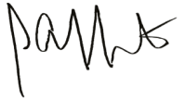
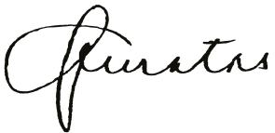

MA. JAEVA C. QUINTAS ENGR. LIONEL ALFREDO A. INFANTE
Chairman Agency Head
SALN Review and Compliance Committee
HRMO-Designate

