Kolambugan Water District
Kolambugan, Lanao del Norte
TIN: 004-365-844 CCC No. 539
Tel. No. (063) 227-5201

Freedom of Information
Manual

TABLE OF CONTENTS

Section 1. Overview

1. Purpose of the Manual
2. Structure of the Manual
3. Coverage of the Manual
4. Responsible Officers

Section 2. Definition of Terms

Section 3. Promotion of Openness in Government

1. Access to Information
2. Protection of Privacy

Section 4. Standard Procedure

1. Request for Information
2. Manner of Making Request
3. Receipt of Request
4. Period to Respond
5. Action by FDM
6. Action by FRO

Section 5. Remedy in Case of Denial

Section 6. Fees and Undertaking

Section 7. Administrative Liability

Section 8. Effectivity

Annexes

A Executive Order No. 02
B Flow Chart
C FOI Request Form
D FOI Appeal Template
E FOI No Wrong Door Policy
F FOI Receiving Officer of the Agency and Local Offices

SECTION 1: OVERVIEW
1. Purpose of the Manual: The purpose of this Freedom of Information (FOI) Manual (Manual) is to provide the process by which the Kolambugan Water District (KOLWD) shall deal with requests of information received under Executive Order No. 2, s. 2016 on FOI. (Annex A)
2. Structure of the Manual: This Manual sets out the definition of terms, standard operating procedures, remedies, fees, and administrative liability. It also provides for the relevant forms and other annexes.
3. Coverage of the Manual: The Manual shall cover all requests for information directed to the KOLWD.
4. Responsible Officers: For purposes of the Manual, there shall be the FOI Receiving Officer (FRO), the FOI Decision Maker (FDM), and the FOI Appellate Authority. The contact details are as follows:
Telephone: (063) 227-5201
Email: kolambuganwaterdistrict@yahoo.com

SECTION 2: DEFINITION OF TERMS
1. INFORMATION shall mean any records, documents, papers, reports, letters, contracts, minutes and transcripts of official meetings, maps, books, photographs, data, research materials, films, sound and video recording, magnetic or other tapes, electronic data, computer stored data, any other like or similar data or materials recorded, stored or archived in whatever format, whether offline or online, which are made, received, or kept in or under the control and custody of any government office pursuant to law, executive order, and rules and regulations or in connection with the performance or transaction of official business by any government office.
2. OFFICIAL RECORDS shall refer to information produced or received by a public officer or employee or by a government office in an official capacity or pursuant to a public function or duty.
3. PUBLIC RECORDS shall include information required by laws, executive orders, rules, or regulations to be entered, kept, and made publicly available by a government office.
4. PERSONAL INFORMATION shall refer to any information, whether recorded in a material form or not, from which the identify of an individual is apparent or can be reasonably and directly ascertained by the entity holding the information, or when put together with other information would directly and certainly identify an individual.
5. SENSITIVE PERSONAL INFORMATION shall be as defined in the Data Privacy Act of 2012 (Republic Act No. 10173), i.e., personal information:
(1) About an individual’s race, ethnic origin, marital status, age, color, and religious philosophical or political affiliations;
(2) About an individual’s health, education, genetic or sexual life of a person, or to any proceedings for any offense committed or alleged to have committed by such person, the disposal of such proceedings or the sentence of any court in such proceedings;
(3) Issued by government agencies peculiar to an individual which includes, but not limited to, social security numbers, previous or current health records, licenses or its denials, suspension or revocation, and tax returns; and
(4) Specifically established by an executive order or an act of Congress to be kept classified.

SECTION 3. PROMOTION OF OPENNESS IN GOVERNMENT
1. Access to Information: The KOLWD recognizes the right of the people to information on matters of public concern and accordingly adopts a policy of full disclosure, subject to the exceptions (Annex A), procedures, and limitations provided in E.O. No. 2 and the Manual. This right is indispensable to the exercise of the right of the people to effective and reasonable participation at all levels of social, political and economic decision-making.
2. Protection of Privacy: While providing for access to information, the KOLWD shall afford full protection to a person’s right to privacy, as follows:
a. The KOLWD shall ensure that personal information, particularly sensitive personal information, in its custody or under its control is disclosed only as permitted by existing laws.
b. The KOLWD shall protect personal information in its custody or under its control by making reasonable security arrangements against unauthorized access, leaks or premature disclosure.
c. The FRO, FDM, or any employee or official who has access, whether authorized or unauthorized, to personal information in the custody of the KOLWD, shall not disclose that information except as authorized by existing laws.
3. Limitations: The right of access to information is without prejudice to the right of the KOLWD to determine whether there are grounds to believe that: the identity of the requesting party is fictitious or otherwise not legitimate based on the credentials provided by him/her, the request is prompted by sheer idle curiosity, the request is being made with a plainly discernible improper motive such as harassment, the purpose of the request is contrary to law, morals, good customs or public policy, or the request is for any commercial purpose.

SECTION 4. STANDARD PROCEDURE
1. Request for Information: All requests for information shall:
(1) Be in writing and be accomplished using the prescribed request form; (Annex C)
(2) Provide the full name and contact information of the requesting party including a valid government identification card with photograph and signature; and
(3) Reasonably describe the information requested, and the reason for, or purpose of, the request for information.
The request form shall be made available in the office of the KOLWD and on the KOLWD website.
2. Manner of Making Request: A request for information shall be made by the requesting party by delivering it personally to the KOLWD Office, by sending it by mail, or by sending it by electronic email (kolambuganwaterdistrict@yahoo.com) or contact Ms. Ana Lou T. Cabugnason, the Receiving Officer with the following numbers 09264233248.
In case the requesting party is unable to make a written request because of illiteracy or disability, he/she may make an oral request and the FRO shall reduce it into writing. The requesting party shall sign the form.
3. Receipt of Request: A complete request for information shall be signed and stamped received by the FRO after it has been delivered to him/her by the personnel who actually received the request. The FRO shall indicate the date and time of receipt and the name, rank, title and position of the said personnel at the receiving station.
The date of receipt shall be:
(1) The date when the request is personally delivered to the KOLWD;
(2) The date when the request is received by mail by the KOLWD; or
(3) The date when the request is electronically received by the KOLWD.
4. Period to Respond:
4.1 The KOLWD shall respond to the requesting party within fifteen (15) working days from the date of receipt of the request.
4.2 A working day is any day other than a Saturday, Sunday, or a day which is declared a national public holiday in the Philippines. In computing for the period, Art. 13 of the Civil Code shall be observed.
4.3 The period may be extended whenever the request requires extensive search of the records facilities of the KOLWD or examination of voluminous records, or in case of the occurrence of fortuitous events, or other analogous cases. The FRO shall inform the requesting party of the extension, setting forth the reason for such extension.
In no case shall the extension exceed twenty (20) working days, unless exceptional circumstances warrant a longer period.
5. Action by FDM: The FRO shall forward the request for information to the FDM and record the date and time it was forwarded.
Upon receipt of the request for information from the FRO, the FDM shall assess the request. The FDM’s action shall be relayed by the FRO to the requesting party.
5.1 Approval of Request: In case of approval of the request by the FDM, the FRO shall collate the information and document, notify the requesting party, and direct the requesting party to get the information and document at the KOLWD office on the designated day and time and pay any applicable fees.
5.2 Process of Referral: When the requested information is not in the possession of the KOLWD or any of its offices, the FRO shall take the following actions upon referral and discussions with the FDM:
(i) if KOLWD (government agency no. 1 or GA1) does not have the requested information, but is available in another government agency (government agency no. 2 or GA2) under the Executive Branch, the request shall be immediately referred by GA1 to GA2 through the most expeditious manner but not exceeding three (3) working days from the receipt of the request. This shall be considered as the “First Referral” and a fresh period will apply. (Annex E)
Referral to the appropriate government agency shall mean that another government office is the proper repository or custodian of the requested information or records, or have control over the said information or records.
(ii) if GA1 fails to refer the request within three (3) working days upon its receipt, the FRO shall act on it within the remaining period to respond pursuant to EO No. 02, s. 2016. No fresh period shall apply.
(iii) if GA1, in good faith, erroneously referred the request to GA2, the latter shall immediately notify the former as well as the requesting party, that the information requested is not available in their agency.
(iv) GA2, to whom the request was referred under the First Referral may subsequently refer the request to another government agency (government agency no. 3 or GA3) under the procedure set forth in the first paragraph of this Section. This shall be considered as the “Second Referral” and another fresh period shall apply.
(v) Referrals under this Order shall only be limited to two (2) subsequent transfers of request. A written or email acknowledgement of the referral shall be made by the FRO of the government agency where it was referred.
(vi) The requesting party shall be notified of the referral and must be provided with the reason or rationale thereof, and contact details of the government office where the request was referred.
5.2 Denial of Request: On the following grounds, the FDM may deny a request:
(i) the request is not complete or not valid, in which case the requesting party shall be notified accordingly;
(ii) the requested information is substantially similar or identical to a previous request by the requesting party, whether the same has been granted or not, in which case the requesting party shall be notified accordingly;
(iii) the requested information is already available on the KOLWD website, in which case the requesting party shall be notified accordingly and provided with the website link where the information is posted, if known;
(iv) the requested information refers to another government agency, in which case the requesting party shall be notified accordingly and provided with the contact details of that office, if known;
(v) the reason for the request is contrary to laws, rules, or regulations, in which case the requesting party shall be notified accordingly;
(vi) the request falls under the exceptions under the Inventory of Exceptions issued by the Office of the President, in which case the requesting party shall be notified accordingly;

SECTION 5. REMEDY IN CASE OF DENIAL
1. In case of denial of a request for information, the requesting party may appeal to the FOI Appellate Authority. The appeal shall be in writing, signed by the requesting party, citing the ground for the appeal, with copies of the request for information and the notice of denial attached, and shall be filed within fifteen (15) working days from the notice of denial. (Annex D)
2. The appeal shall be decided by the FOI Appellate Authority within thirty (30) working days from receipt of the appeal, unless circumstances warrant a longer period. In no case shall the extension exceed twenty (20) working days.

SECTION 6. FEES AND UNDERTAKING
1. No Request Fee: The KOLWD shall not charge any fee for accepting requests for information.
2. Reasonable Cost of Reproduction, Scanning, and Mailing: The KOLWD may charge a reasonable fee to reimburse necessary costs, including costs of reproduction, scanning, and mailing of the information or documents required. Before the party receives the requested information and document, proof of payment must first be provided to the KOLWD.
3. Undertaking: By receiving the requested information and document, the requesting party acknowledges that the same shall not be used for any purpose other than what is indicated in the request form as approved, shall not be used for any purpose that is contrary to law, morals, good customs, or public policy, and shall not be reproduced for any commercial use.

SECTION 7. ADMINISTRATIVE LIABILITY
1. Non-compliance with FOI: Failure to comply with the provisions of this Manual shall be a ground for the following administrative penalties:

a. 1st Offense - Reprimand
b. 2nd Offense - Suspension of one day to thirty days
c. 3rd Offense - Suspension of one month to six months
d. 4th Offense - Dismissal from the service

2. Procedure: The Revised Rules on Administrative Cases in the Civil Service shall be applicable in the disposition of cases under this Manual.

SECTION 8. EFFECTIVITY
This Manual shall be posted on the KOLWD website and shall take effect immediately.

APPROVAL
This Freedom of Information Manual, as amended, was signed and approved on January 27, 2022 by:

(SGD.) MA. JAEVA C QUINTAS
Acting General Manager
Kolambugan Water District

ANNEX A
MALACAÑAN PALACE
MANILA
BY THE PRESIDENT OF THE PHILIPPINES
EXECUTIVE ORDER NO. 02
OPERATIONALIZING IN THE EXECUTIVE BRANCH THE PEOPLE’S CONSTITUTIONAL RIGHT TO INFORMATION AND THE STATE POLICIES TO FULL PUBLIC DISCLOSURE AND TRANSPARENCY IN THE PUBLIC SERVICE AND PROVIDING GUIDELINES THEREFOR
WHEREAS, pursuant to Section 28, Article II of the 1987 Constitution, the State adopts and implements a policy of full public disclosure of all its transactions involving public interest, subject to reasonable conditions prescribed by law;
WHEREAS, Section 7, Article III of the Constitution guarantees the right of the people to information on matters of public concern;
WHEREAS, the incorporation of this right in the Constitution is a recognition of the fundamental role of free and open exchange of information in a democracy, meant to enhance transparency and accountability in government official acts, transactions, or decisions;
WHEREAS, the Executive Branch recognizes the urgent need to operationalize these Constitutional provisions;
WHEREAS, the President, under Section 17, Article VII of the Constitution, has control over all executive departments, bureaus and offices, and the duty to ensure that the laws be faithfully executed;
WHEREAS, the Data Privacy Act of 2012 (R.A. 10173), including its implementing Rules and Regulations, strengthens the fundamental human right of privacy, and of communication while ensuring the free flow of information to promote innovation and growth;
NOW, THEREFORE, I, RODRIGO ROA DUTERTE, President of the Philippines, by virtue of the powers vested in me by the Constitution and existing laws, do hereby order:
SECTION 1. Definition. For the purpose of this Executive Order, the following terms shall mean:
(a) “Information” shall mean any records, documents, papers, reports, letters, contracts, minutes and transcripts of official meetings, maps, books, photographs, data, research materials, films, sound and video recording, magnetic or other tapes, electronic data, computer stored data, any other like or similar data or materials recorded, stored or archived in whatever format, whether offline or online, which are made, received, or kept in or under the control and custody of any government office pursuant to law, executive order, and rules and regulations or in connection with the performance or transaction of official business by any government office.
(b) “Official record/records” shall refer to information produced or received by a public officer or employee, or by a government office in an official capacity or pursuant to a public function or duty.
(c) “Public record/records” shall include information required by laws, executive orders, rules, or regulations to be entered, kept and made publicly available by a government office.
SECTION 2. Coverage. This order shall cover all government offices under the Executive Branch, including but not limited to the national government and all its offices, departments, bureaus, offices, and instrumentalities, including government-owned or -controlled corporations, and state universities and colleges. Local government units (LGUs) are encouraged to observe and be guided by this Order.
SECTION 3. Access to information. Every Filipino shall have access to information, official records, public records and to documents and papers pertaining to official acts, transactions or decisions, as well as to government research data used as basis for policy development.
SECTION 4. Exception. Access to information shall be denied when the information falls under any of the exceptions enshrined in the Constitution, existing law or jurisprudence.
The Department of Justice and the Office of the Solicitor General are hereby directed to prepare an inventory of such exceptions and submit the same to the Office of the President within thirty (30) calendar days from the date of effectivity of this Order.
The Office of the President shall thereafter, immediately circularize the inventory of exceptions for the guidance of all government offices and instrumentalities covered by this Order and the general public.
Said inventory of exceptions shall periodically be updated to properly reflect any change in existing law and jurisprudence and the Department of Justice and the Office of the Solicitor General are directed to update the inventory of exceptions as the need to do so arises, for circularization as hereinabove stated.
SECTION 5. Availability of SALN. Subject to the provisions contained in Sections 3 and 4 of this Order, all public officials are reminded of their obligation to file and make available for scrutiny their Statements of Assets, Liabilities and Net Worth (SALN) in accordance with existing laws, rules and regulations, and the spirit and letter of this Order.
SECTION 6. Application and Interpretation. There shall be a legal presumption in favor of access to information, public records and official records. No request for information shall be denied unless it clearly falls under any of the exceptions listed in the inventory or updated inventory of exceptions circularized by the Office of the President provided in the preceding section.
The determination of the applicability of any of the exceptions to the request shall be the responsibility of the Head of the Office which is in custody or control of the information, public record or official record, or the responsible central or field officer duly designated by him in writing.
In making such determination, the Head of the Office or his designated officer shall exercise reasonable diligence to ensure that no exception shall be used or availed of to deny any request for information or access to public records, or official records if the denial is intended primarily and purposely to cover up a crime, wrongdoing, graft or corruption.
SECTION 7. Protection of Privacy. While providing access to information, public records, and official records, responsible officials shall afford full protection to the right to privacy of the individual as follows:
(a) Each government office per Section 2 hereof shall ensure that personal information in its custody or under its control is disclosed or released only if it is material or relevant to the subject-matter of the request and its disclosure is permissible under this order or existing law, rules or regulations;
(b) Each government office must protect personal information in its custody or control by making reasonable security arrangements against leaks or premature disclosure of personal information which unduly exposes the individual whose personal information is requested, to vilification, harassment or any other wrongful acts.
(c) Any employee, official or director of a government office per Section 2 hereof who has access, authorized or unauthorized, to personal information in the custody of the office, must not disclose that information except when authorized under this order or pursuant to existing laws, rules or regulation.

SECTION 8. People’s Freedom to Information (FOI) Manual. For the effective implementation of this Order, every government office is directed to prepare within one hundred twenty (120) calendar days from the effectivity of this Order, its own People’s FOI Manual, which shall include among others the following provisions:
(a) The location and contact information of the head, regional, provincial, and field offices, and other established places where the public can obtain information or submit requests;
(b) The person or office responsible for receiving requests for information;
(c) The procedure for the filing and processing of the request as specified in the succeeding section 8 of this Order.
(d) The standard forms for the submission of requests and for the proper acknowledgment of requests;
(e) The process for the disposition of requests;
(f) The procedure for the administrative appeal of any denial for access to information; and
(g) The schedule of applicable fees.

SECTION 9. Procedure. The following procedure shall govern the filing and processing of request for access to information:
(a) Any person who requests access to information shall submit a written request to the government office concerned. The request shall state the name and contact information of the requesting party, provide valid proof of his identification or authorization, reasonably describe the information requested, and the reason for, or purpose of, the request for information: Provided, that no request shall be denied or refused acceptance unless the reason for the request is contrary to law, existing rules and regulations or it is one of the exceptions contained in the inventory or updated inventory of exception as hereinabove provided.
(b) The public official receiving the request shall provide reasonable assistance, free of charge, to enable, to enable all requesting parties and particularly those with special needs, to comply with the request requirements under this Section.
(c) The request shall be stamped by the government office, indicating the date and time of receipt and the name, rank, title and position of the receiving public officer or employee with the corresponding signature, and a copy thereof furnished to the requesting party. Each government office shall establish a system to trace the status of all requests for information received by it.
(d) The government office shall respond to a request fully compliant with requirements of sub-section (a) hereof as soon as practicable but not exceeding fifteen (15) working days from the receipt thereof. The response mentioned above refers to the decision of the agency or office concerned to grant or deny access to the information requested.
(e) The period to respond may be extended whenever the information requested requires extensive search of the government office’s records facilities, examination of voluminous records, the occurrence of fortuitous cases or other analogous cases. The government office shall notify the person making the request of the extension, setting forth the reasons for such extension. In no case shall the extension go beyond twenty (20) working days unless exceptional circumstances warrant a longer period.
(f) Once a decision is made to grant the request, the person making the request shall be notified of such decision and directed to pay any applicable fees.
SECTION 10. Fees. Government offices shall not charge any fee for accepting requests for access to information. They may, however, charge a reasonable fee to reimburse necessary costs, including actual costs of reproduction and copying of the information required, subject to existing rules and regulations. In no case shall the applicable fees be so onerous as to defeat the purpose of this Order.
SECTION 11. Identical or Substantially Similar Requests. The government office shall not be required to act upon an unreasonable subsequent identical or substantially similar request from the same requesting party whose request from the same requesting party whose request has already been previously granted or denied by the same government office.
SECTION 12. Notice of Denial. If the government office decides to deny the request, in whole or in part, it shall as soon as practicable, in any case within fifteen (15) working days from the receipt of the request, notify the requesting party the denial in writing. The notice shall clearly set forth the ground or grounds for denial and the circumstances on which the denial is based. Failure to notify the requesting party of the action taken on the request within the period herein stipulated shall be deemed a denial of the request for access to information.
SECTION 13. Remedies in Cases of Denial of Request for Access to Information.
(a) Denial of any request for access to information may be appealed to the person or office next higher in the authority, following the procedure mentioned in Section 7 (f) of this Order: Provided, that the written appeal must be filed by the same person making the request within fifteen (15) working days from the notice of denial or from the lapse of the relevant period to respond to the request.
(b) The appeal be decided by the person or office next higher in authority within thirty (30) working days from the filing of said written appeal. Failure of such person or office to decide within the afore-stated period shall be deemed a denial of the appeal.
(c) Upon exhaustion of administrative appeal remedies, the requesting part may file the appropriate case in the proper courts in accordance with the Rules of Court.
SECTION 14. Keeping of Records. Subject to existing laws, rules, and regulations, government offices shall create and/or maintain accurate and reasonably complete records of important information in appropriate formats, and implement a records management system that facilitates easy identification, retrieval and communication of information to the public.
SECTION 15. Administrative Liability. Failure to comply with the provisions of this Order may be a ground for administrative and disciplinary sanctions against any erring public officer or employee as provided under existing laws or regulations.
SECTION 16. Implementing Details. All government offices in the Executive Branch are directed to formulate their respective implementing details taking into consideration their mandates and the nature of information in their custody or control, within one hundred twenty (120) days from the effectivity of this Order.
SECTION 17. Separability Clause. If any section or part of this Order is held unconstitutional or invalid, the other sections or provisions not otherwise affected shall remain in full force or effect.
SECTION 18. Repealing Clause. All orders, rules and regulations, issuances or any part thereof inconsistent with the provisions of this Executive Order are hereby repealed, amended or modified accordingly: Provided, that the provisions of Memorandum Circular No. 78 (s. 1964), as amended, shall not be deemed repealed pending further review.
SECTION 19. Effectivity. This Order shall take effect immediately upon publication in a newspaper of general circulation.
DONE, in the City of Manila, this 23rd day of July in the year of our Lord two thousand and sixteen.
(Sgd.) RODRIGO ROA DUTERTE
President of the Philippines
By the President:
(Sgd.) SALVADOR C. MEDIALDEA
Executive Secretary

ANNEX B

FLOW CHART

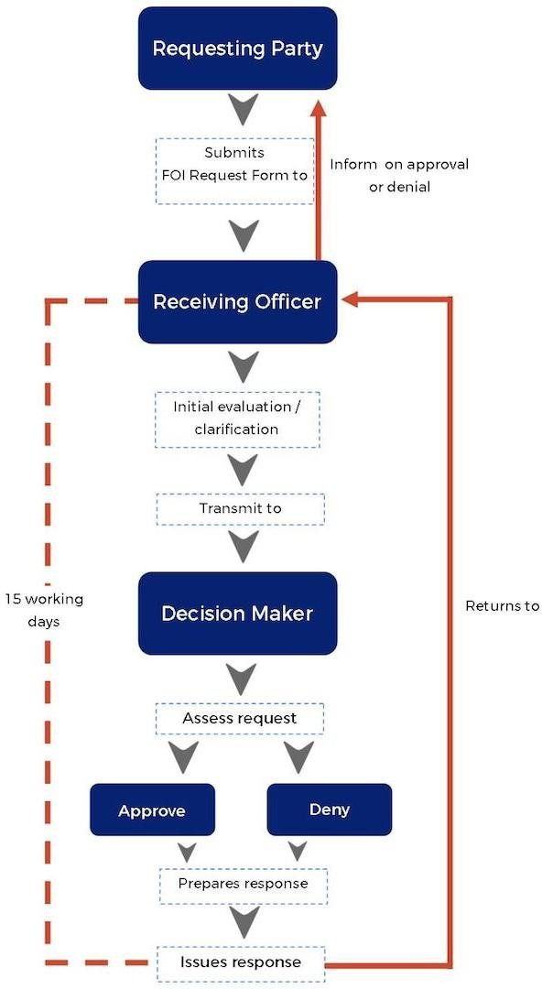
ANNEX B
FOI REQUEST FORM

ANNEX C

FOI REQUEST FORM
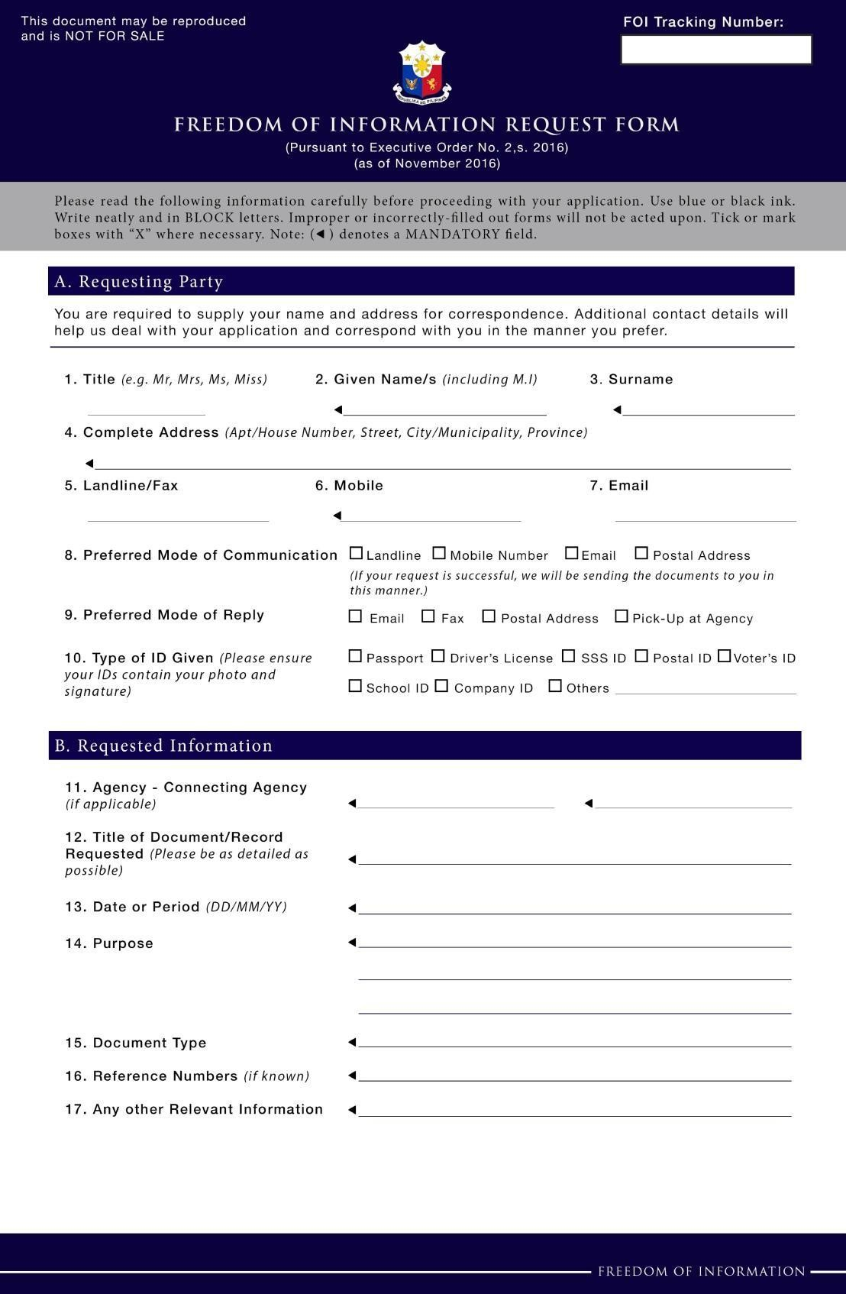

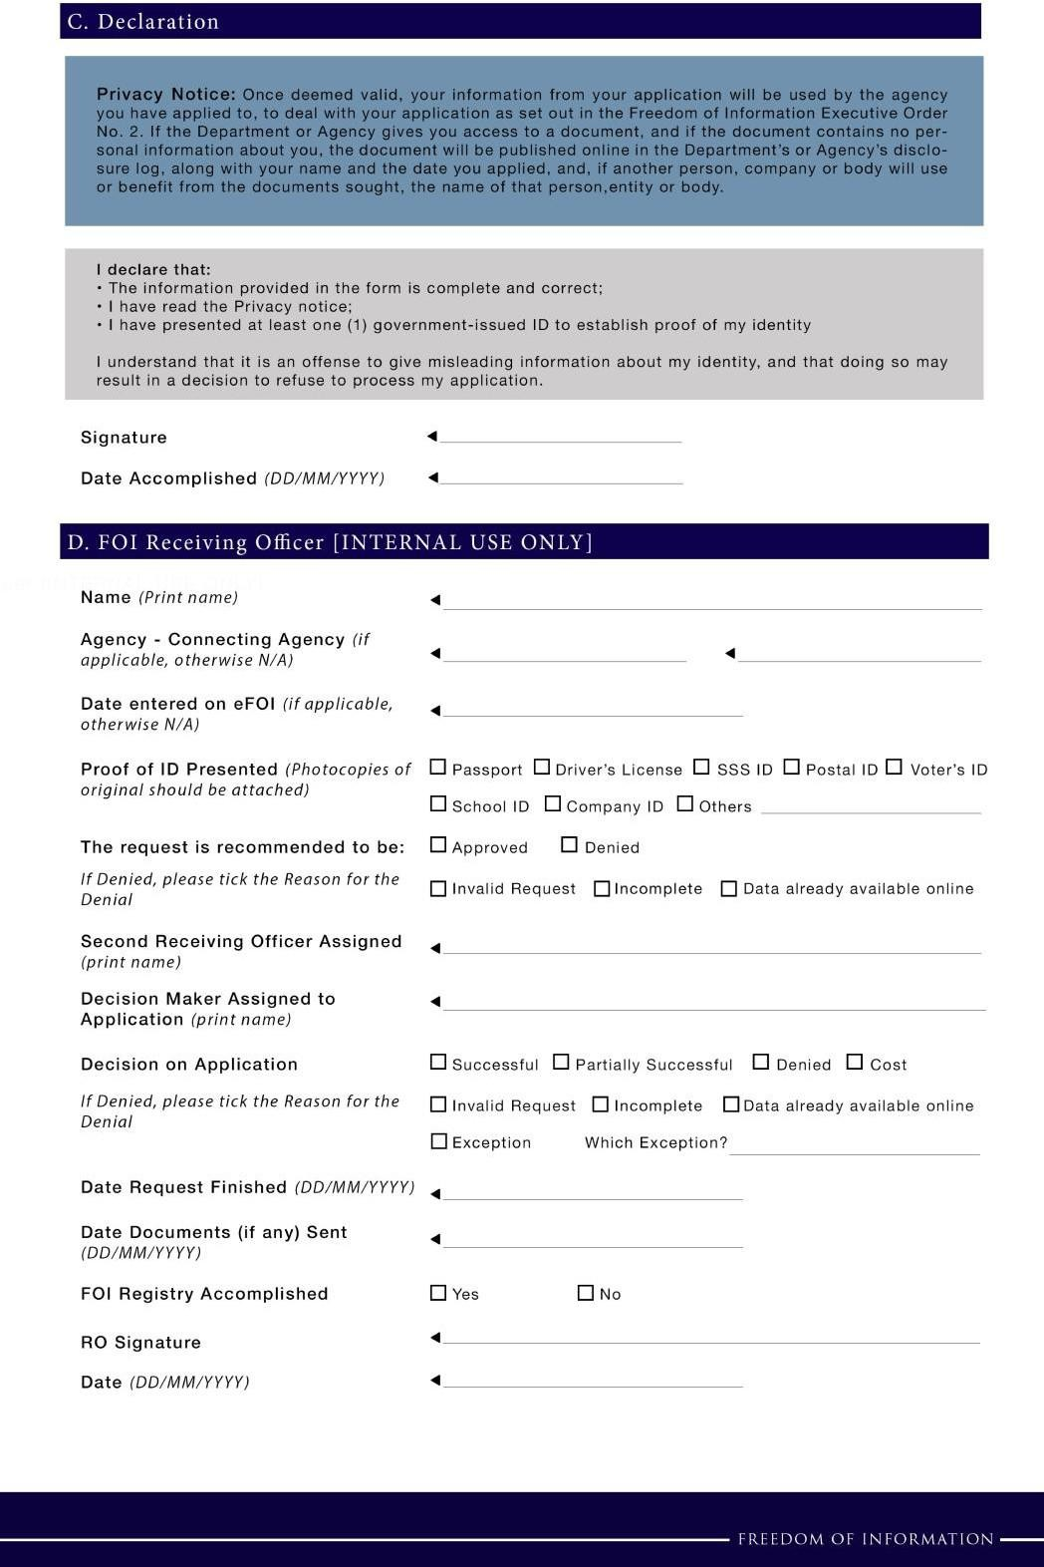

ANNEX D

FOI APPEAL TEMPLATE

[Date]

Kolambugan Water District
Kolambugan, Lanao del Norte

Dear Sir/Ma’am,
I submitted a request for information dated ________________________ asking for __________________________. Attached is a copy.
On ___________________, I received a notice denying the request for the following reason: ____________________. Attached is a copy.
I would like to appeal this denial on the following ground: ___________________.
This appeal is being filed within fifteen (15) working days from receipt of the notice of denial.

Thank you.

Respectfully,

Requesting Party

ANNEX E

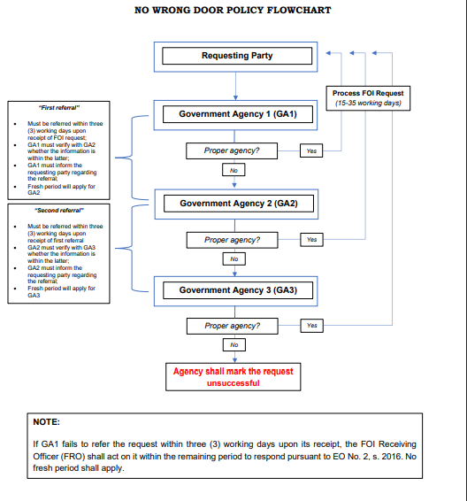
ANNEX F

FOI Receiving Officer of the KOLWD and its local office
Contact Details | Location of FOI Receiving Office | Contact Details | FOI Receiving Officer
Kolambugan Water District | Poblacion, Kolambugan, Lanao del Norte, 9204 | 09264233248  (063) 227-5201  kolambuganwaterdistrict@yahoo.com | Ana Lou T. Cabugnason

