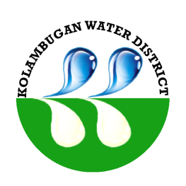
Republic of the Philippines
Kolambugan Water District
(GOVERNMENT OWNED & CONTROLLED CORP.)
Kolambugan, Lanao del Norte
TIN: 004-365-844 CCC No. 539
Tel. No. (063) 227-5201

CERTIFICATE OF NO PHILGEPS POSTING

This is to certify that KOLAMBUGAN WATER DISTRICT, Kolambugan Lanao del Norte had no procurement of materials and office supplies above ONE MILLION PESOS for calendar year 2023.

IN WITNESS WHEREOF, we have hereunto affixed our signatures on the 19th day of January 2024 at Kolambugan (Lanao del Norte) Water District Office, Kolambugan, Lanao del Norte, Philippines.

Signed by: Signed by:

RAINIER B. CASAS ENGR. ISAGANE J. SOTTO
BAC – Chairperson General Manager
Date: January 19, 2024 Date: January 19, 2024

